# Advanced Scrum Tutorial Status

**Epics**:

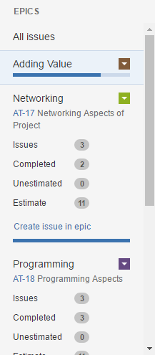

**Custom Workflow**: We have not yet added custom workflows; this seems to need an admin account for configuration.

**Velocity Chart**:

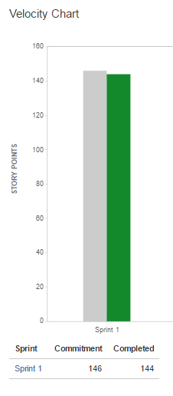

**Wallboards**: